**Artificial Intelligence**

**Assignment 1:** **Blind and Informed Search Algorithms**

Assignment 1 Blind and Informed search algorithm focuses on implementation of two search algorithms namely Iterative Deepening (IDDFS) for Blind Search and A* Algorithm for Informed Search in order to solve 8 puzzle problem.

**Problem Description:**

We are given a 3*3 Matrix with random numbers arranged from 0 to 8 where the number 8 represents the empty tile. The goal of the problem is to provide a sequence of indexes with which the tile of number 8 i.e., the empty tile should be swapped to as to reach a goal state i.e., [0,1,2,3,4,5,6,7,8]

**Iterative Deepening Algorithm:**

1. The Iterative deepening Algorithm uses depth first search algorithm with limited depth height in order to find the goal state.
2. It explores the state space iteratively with increasing depth limits until a solution is found
3. Iterative Deepening Algorithm also makes use of neighbours () function in order to find the neighbours of current state.

**A Star Algorithm:**

1. A Star Algorithm is an example of Informed Search
2. A Star Algorithm makes use of Heuristic function in order to determine the next state to be considered
3. The next state considered in each iteration is the state with lowest cost
4. A Star Algorithm makes use of neighbours () function in order to find the neighbours of current state.

**Achievement:**

Iterative Deepening Algorithm and A Star Algorithm both find an optimal solution to 8 Puzzle problem.

**Limitation:**

* Iterative Deepening Algorithm is not efficient for large state spaces and time required to solve large state spaces may be huge
* A* algorithm although better than Iterative Deepening may still take time to solve complex problems

**Example 1: Iterative Deepening Output**

Initial State:

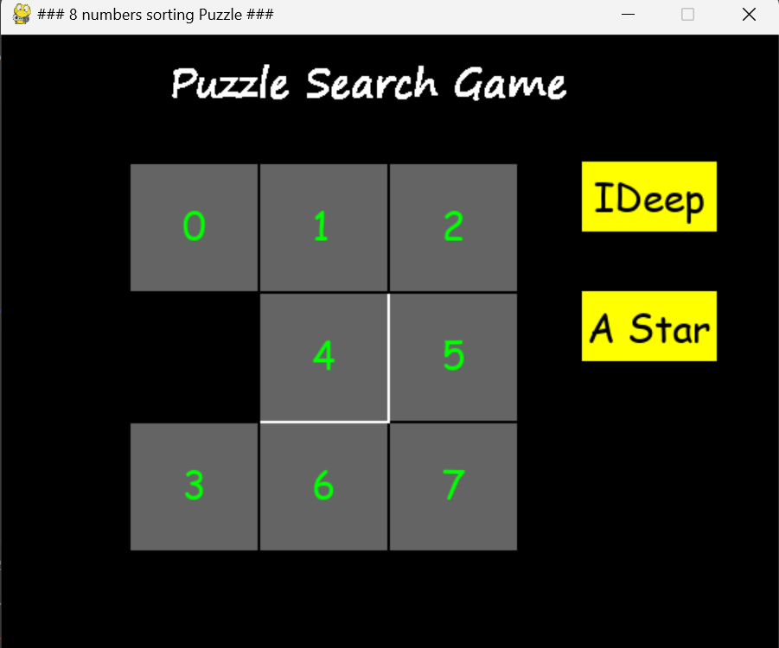

Solved State:

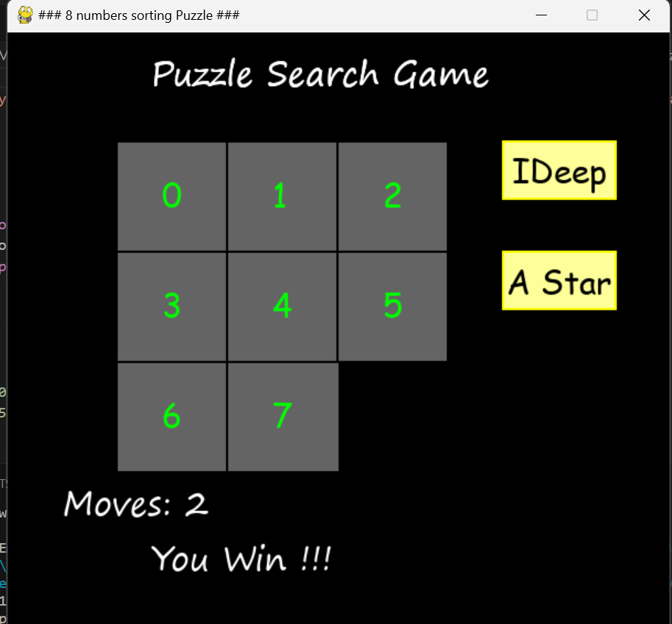

Terminal Output:

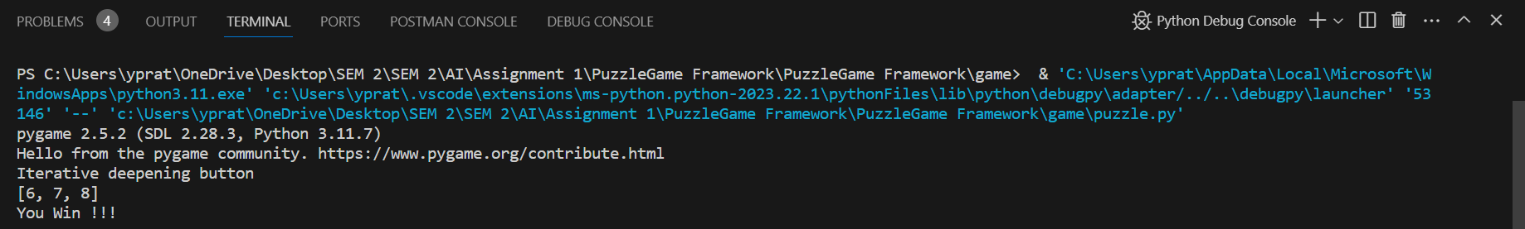

**Example 2: A * Algorithm Output**

Initial State

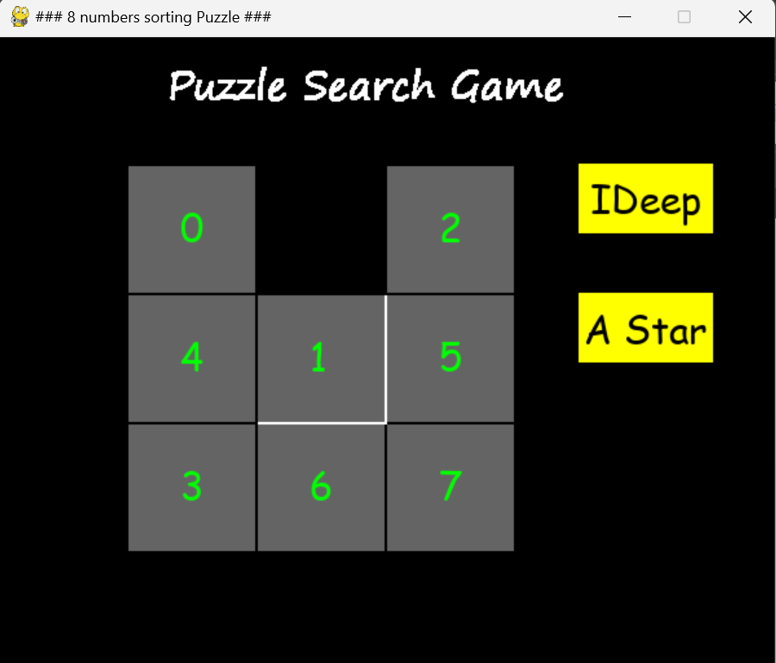

Solved State

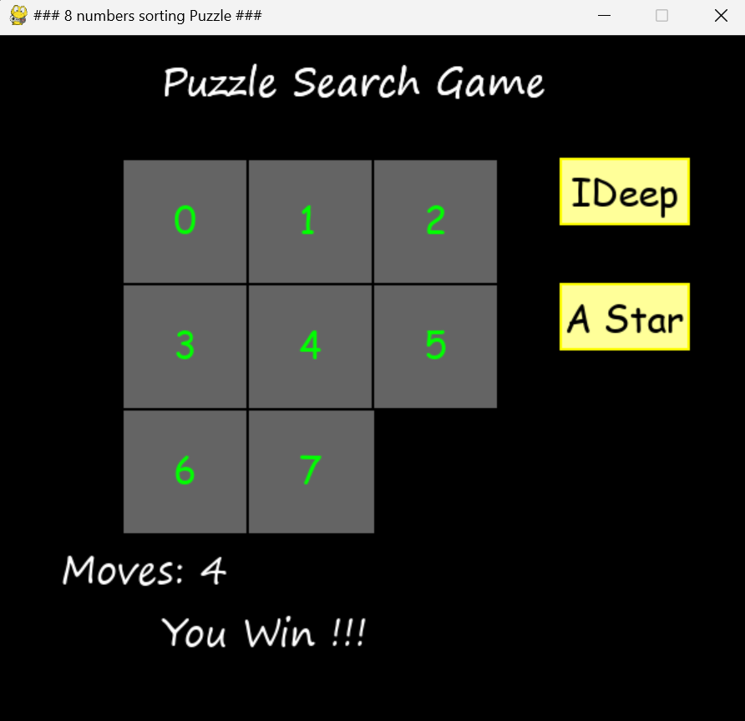

Terminal:

